Examine Facebook Marketing API

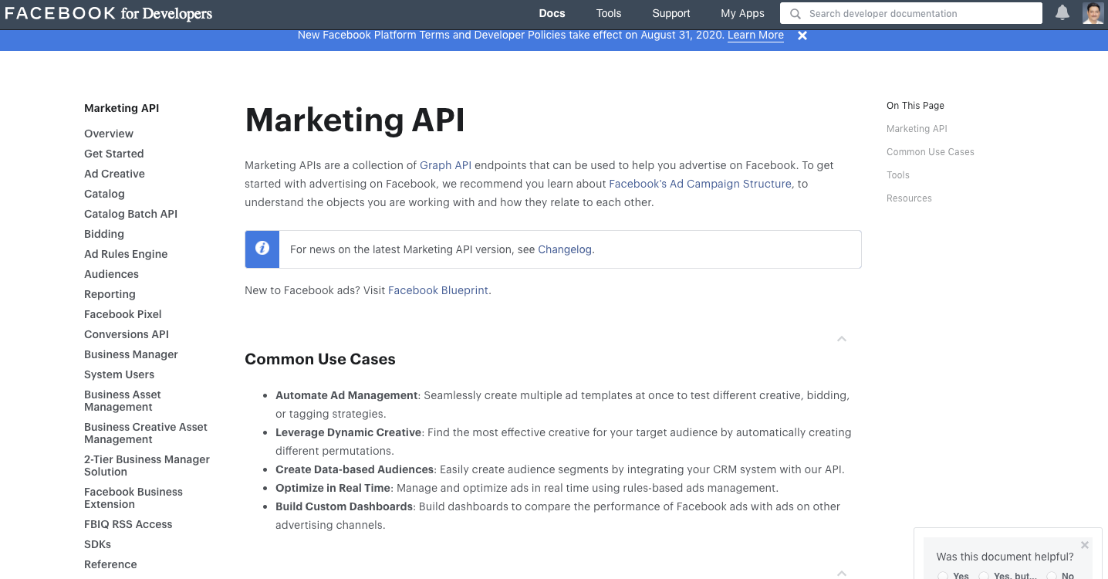

https://developers.facebook.com/docs/marketing-api/etags

Play with Etags

<https://devcenter.heroku.com/articles/increasing-application-performance-with-http-cache-headers>

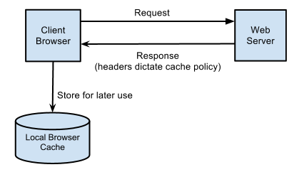

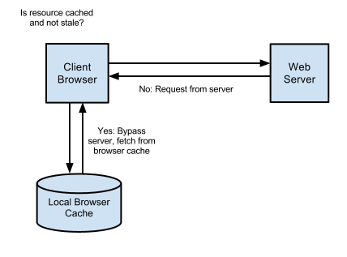

http://http-caching-demo.herokuapp.com/

http://http-caching-demo.herokuapp.com/?cache=true

http://http-caching-demo.herokuapp.com/?etag=true

